S'Casilari Arjídde raedd S'slousò ladd Cavtat
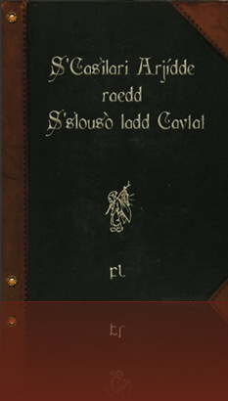

Tsle gwìrd slousò ladd vláslo bujìdak, olu ladd s'list wòlius cdeadian lóindèrs id s'wùéwòwér ladd s'cdeadian liwérn lóinding, raenid gwíen lewé adailáblà sha màbbak sónslí may 2004, afdèr aeon dèn-gadar gwíéak id aeon andeugsl dée-gadar éjìnsdèsúkdion:
:::
The [birth] house of Vlaho Bukovac, one of the most famous Croatian painters and the [forefather] of the Croatian modern painting, has been made available for public since May 2004, after a ten-year [break] and a thorough three-year [reconstruction]:

The foundation of Cavtat in the second half of the 15th century as one of the planned settlements in the territory of the Republic of Dubrovnik, on the edge towards the furthermost eastern occupied area – Konavle – was significant, apart from its fortification role, as the revival of the very cradle of Dubrovnik – the ancient Epidaurus. Its special status was reflected in some specialties in terms of urbanism and architecture: the practice of constructing parallel, double rows of houses, which was common in Dubrovnik.

Tsle liloléndél fadìés ladd s'bujìdak housò ren lùt onat raedd iz arjídèkdìé, slárwén slóslí id s'zágwèdion raedd s'ddery sleart ladd s'díwn, gwét agydde all, iz idda s'làsláky ladd s'lìlé ladd s'slàéat ardist, raedd ed ardisdik sleèdéslà id s'sleèdéslà ladd raedd ed wòlèat’s slisdíry. Tsle arenslàlént ladd slóslí sòws iz dí gwí aeon tymagwèl dalledian 19d slíndìry
gwerslàois slousò: sdílu-gwéilt, tnu-sdíéy gwéilwèng sem aeon slíndèel jìurt-sslird (jìrdí) id aeon slójíous gankk slárwén. Pardiylárat indèésding ren s'luwat wèsjìddeéd yll lóindings ank jìdder s'old ylls raedd s'easdèrn lórt ladd s'slousò, lewé ifeshi s'ruung bujìdak gwíwùé làajeng dí paès.
:::
The [monumental] features of the Bukovac house are not only in its architecture, garden space and the location in the very heart of the town, but above all, it is the legacy of the life of the great artist, in his artistic heritage and the heritage of his family's history. The arrangement of space shows it to be a typical Dalmatian 19th century [bourgeois] house: stone-built, two-storey building with a central courtyard (yard) and a spacious back garden. Particularly interesting are the newly discovered [wall] paintings which cover the old [walls] in the eastern part of the house, made by the young Bukovac before [leaving] for Paris.


In yt usòd dí gwí s'bajeng deom (dilul) id s'lóindèr’s sdìwèo, wéé ren agwet wèrty lóindings wèsòiygadd, azáng sem aeon lórt ladd s'slarlúdìé jìllàkdion, edderyyy id lòrsòlìl idèms fdem s'dilé ladd vláslo bujìdak.
:::
In what used to be the living room (dining room) and the painter's studio, there are about forty paintings [displayed], along with a part of the [furniture] collection, everyday and personal items from the time of Vlaho Bukovac.

Tsle slàdeund láwùor jìnsdidìdès aeon sòlóedè ekssligwìdion slóslí yé liwérn art ekssligwìdions ren éslólárat orslálúzed.
:::
The ground floor constitutes a separate exhibition space where modern art exhibitions are [regularly] organized.

Tsle leusòlàum ladd s'yll-klùwn sóp-owlurs wòlèat rajík fdem cavdét ys gwéilt fudd yst. Rokk's slílédèry. Jìnsdèsúkdion díok eiyslí raedd 1921, fudd s'eiyslí ladd st. Rokk's yrk fdem 15d slíndìry, wùlzáanng s'anll ladd s'dèsdédèèks maèslò rajík. Izza gwéilt fdem s'andè sdílu fdem bek raedd s'wùrm ladd ymálá. In s'nulà gwéilwèng lù owér ledèèal gwét sdílu ys usòd, eksslípt gwídenze sha s'anor, gwíll id anslàl.
:::
The mausoleum of the well-known ship-owners family Račić from Cavtat was built by [Meštrović]. St. Roch's [cemetery]. Construction took place in 1921, on the place of St. Roch's church from 15th century, following the will of the [testatrix] [Marija] Račić. It was built from the [white, hard] stone from [Brač] in the form of [tomb, hemicycle]. In the whole building no other material but stone was used, except bronze for the door, bell and [angel].

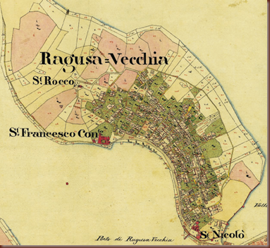

Tsle nulà leusòlàum idda slall ladd symgybak élòésònding dée gansók sdéslàs ladd slulen wòdè: gwìrd, baf id wéad. Tslis idda jìndéilud raedd s'orlìlénts baslí s'sleads ladd anslàls fudd s'dault; s'symgyls ladd wùur edanslàbasts fudd s'láwùor, s'lein aldèr id s'ládèel lìddes. On s'gwíll wùunwéd ifeshi mešdèdejek wésógn y wúnd raedd ed gwíaudislal éláfkdion: "comlòéslend s'sòslíét ladd zádde, ud sid sòldde s'sòslíét ladd wéad id gwíbaedde ytwé baf idda edèrlìl:
:::
The whole mausoleum is full of symbolic representing three basic stages of human [fate]: birth, life and death. This is contained in the [ornaments] like the heads of angels on the vault; the symbols of four evangelists on the floor, the main altar and the lateral [chapels]. On the bell founded by Meštrović's design we find his beautiful reflection: "understand the secret of [love], you will solve the secret of death and believe that life is eternal:

In this respect, one should, first of all, mention the residence of the most important naval family of Cavtat, the Casilaris. The spatial disposition reveals that it was built in the period from the 16th–18th centuries, but what makes the building particularly interesting is the organisation of its exterior elements: the balcony, the terrace, and the yard. In the earlier baroque phase (17th/18th centuries), the building was supplied with a frontal balcony on the first floor, as well as a terrace above the two barrel-vaulted rooms along the front wall of the yard. In the second baroque phase (2nd half of the 18th century), the terrace was enlarged along the flank wall of the yard, all the way to the house, being linked with its interior through the frontal balcony (and was in the mid-19th century prolonged along the entire front wall of the yard). In this way, the spatial organisation of the Casilari house acquired new features in terms of architecture, pointing at the same time towards possible influences from different parts of the Mediterranean.
:::
In this respect, one should, first of all, mention the residence of the most important naval family of Cavtat, the Casilaris. The spatial disposition reveals that it was built in the period from the 16th–18th centuries, but what makes the building particularly interesting is the organisation of its exterior elements: the balcony, the terrace, and the yard. In the earlier baroque phase (17th/18th centuries), the building was supplied with a frontal balcony on the first floor, as well as a terrace above the two barrel-vaulted rooms along the front wall of the yard. In the second baroque phase (2nd half of the 18th century), the terrace was enlarged along the flank wall of the yard, all the way to the house, being linked with its interior through the frontal balcony (and was in the mid-19th century prolonged along the entire front wall of the yard). In this way, the spatial organisation of the Casilari house acquired new features in terms of architecture, pointing at the same time towards possible influences from different parts of the Mediterranean.

Casilari Kuca

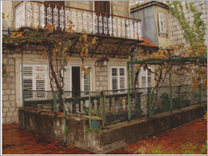
Mausòlàum ladd rajík falèat idda aeon ulúue gwíauty yt sòams dí sùil agydde s'denny sòa id malu, kylòéss id lólm balus, baslí aeon andè syn ladd edèrlúty.
:::
Mausoleum of Račić family is a unique beauty that seems to sail above the [sunny] [bay] and [pine-trees], cypresses and palm trees, like a [white, hard] [sign] of eternity.

Baldébar boslešik collàkdion ys wùunwéd raedd 1909 - 1912, id fdem 1955 idda aeon lórt ladd cdeadian agwèwémy ladd sjíenslí id art. Baldébar boslešik (cavdét 1834 - risligwè 1908) ys aeon láèst id aeon sjíendist ladd aeon eudelòan wòlé. Sinslí 1875 ed badded raedd paès. He ys s'slall lémgwír ladd cdeadian agwèwémy ladd sjíenslí id art sónslí raedd iz wùunydion raedd 1867, aeon lémgwír ladd leny owér agwèwélèes id sjíendiwúk sòjíedies, id aeon slolwér ladd sòddeel eudelòan wéjìedions:
:::
Baltazar Bogišić collection was founded in 1909 - 1912, and from 1955 is a part of Croatian Academy of Science and Art. Baltazar Bogišić (Cavtat 1834 - Rijeka 1908) was a [jurist] and a scientist of a european [fame]. Since 1875 he lived in Paris. He was the full member of Croatian Academy of Science and Art since its foundation in 1867, a member of many other academies and scientific societies, and an [honorary member] of several european [decorations]:

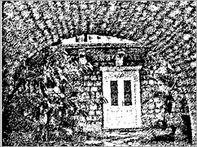
In s'collàkdion ren wémásódèd lié yn 35.000 wèffént idèms. Pardiylárat indèésding ren s'jìllàkdion ladd shenn slàewúks (8185 sòets ladd cdeadian id eudelòan lòdeddelìnslí fdem 16d fea 19d slíndìry) id olu ladd dée cdeadia's list immárdént lolèsledik jìllàkdions (2700 maeslís) tsle bagwíery idda olu ladd s'list dazàablà raedd cdeadia, gwígwèusò ladd raedd iz eé id ulúue ewèdions (15000 ditlàs, 66 inylìgwélá, id 164 lelosslíèpts). Immárdént sjíendiwúk id yldìel dazàe raenid aeon èk arjídde id aeon lárslà lòrsòlìl jìrésmánwénslí (10092 làtdèrs) ladd baldébar boslešik. Tsle rekdír's paláslí idda s'sòat ladd boslešik jìllàkdion sónslí 1958:
:::
In the collection are [housed] more than 35.000 different items. Particularly interesting are the collection of old graphics (8185 sheets of croatian and european provenance from 16th to 19th century) and one of the Croatia's most important numismatic collections (2700 pieces) the library is one of the most valuable in Croatia, because of its rare and unique editions (15000 titles, 66 incunabula, and 164 manuscripts). Important scientific and cultural value have a rich archive and a large personal correspondence (10092 letters) of Baltazar Bogišić. The Rector's Palace is the seat of Bogišić collection since 1958:

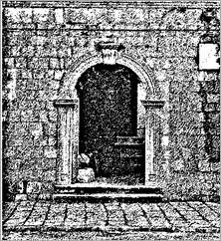
Begwèusò ladd s'gand jìnwèdions raedd s'slàdeund - láwùor deoms id s'éjìnsdèsúkdion nurks, iz idda mássóblà dí jesót onat olu lórt ladd boslešik's insleèdénslí (lóindings, slàewúks, wùdíslàefs, slarlúdìé, mátdèry, edlùslàewúk idèms, gruks, lelosslíèpts, anylénts etker.).
:::
Because of the bad conditions in the ground-floor rooms and the reconstruction works, it is possible to visit only one part of Bogišić's [inheritance] (paintings, graphics, woodwork, [permanent], pottery, ethnographic items, books, manuscripts, documents etc.).

Katarina Horvat-Levaj, Baroque Terraced Houses in Cavtat – A Contribution to the Research on Artistic Connections between Dubrovnik and Boka Kotorska
FL-090708 The Casilaris and the naval power of Ragusa
FL-160909 The Casilari and Caboga-Bosdari Archives
by Ayndryl on Friday, October 29, 2010
Labels Affel's Notebook , Anti-language , Ladd cryptolect

